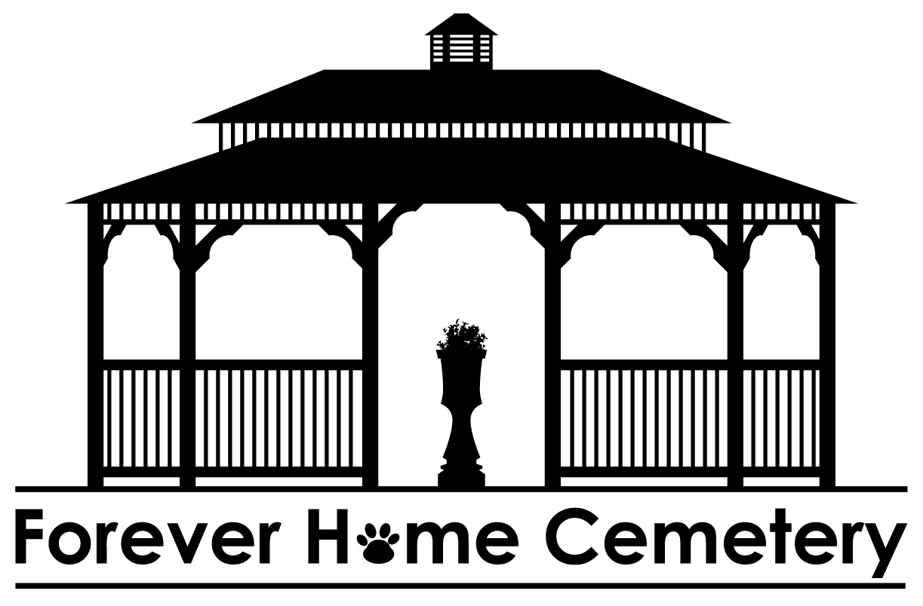
Humane Society of Logan County
Forever Home Cemetery
1801 East Lincoln Parkway
Lincoln, Illinois 62656
217-737-4042
217.737.4042

foreverhomecemetery.org
hslclincoln.org

HSLC FOOD PANTRY POLICY
The Humane Society of Logan County has implemented a new Food Pantry policy requiring an application to be completed annually.

The Food Pantry will operate on Wednesdays and Saturdays from 10a-2p by appointment only. You must call ahead and provide a photo ID on each visit. You must also provide one of the following proofs of need on each visit.

- A Photo ID is required with each visit along with one of the below listed items.

- Proof of Food Stamps (SNAP or LINK Cards)

- Proof of Social Security Disability (SSD)

- Proof of Supplemental Security Income (SSI)

- Proof of Veteran’s Administration Disability Benefits (VA)

You will be permitted to visit the Food Pantry no more than twice a month.

You must be a resident of Logan County to receive food from Food Pantry.

HSLC will not deliver food and we will not leave food outside or in the entryway.

Acquiring any new animals during the time you are receiving food from the Food Pantry will eliminate you from continued access.

Effective 8/1/23

